State Property Office Employee Assistance Program (EAP) and Member Portal

Through AllOne Health, your EAP provides access to the following services:

- Easily access any of three different ways:
- Toll-free number – (800) 638-3327
- Online member portal - https://fei.mylifeexpert.com
- Our mobile app - Member Portal Introduction - AllOne Health - YouTube
- You have access to:
- Mental Health Support
- Life Coaching Services
- Work-Life Resources
- Legal Referrals
- Financial Consultation
- Personal Assistant
- Medical Advocacy
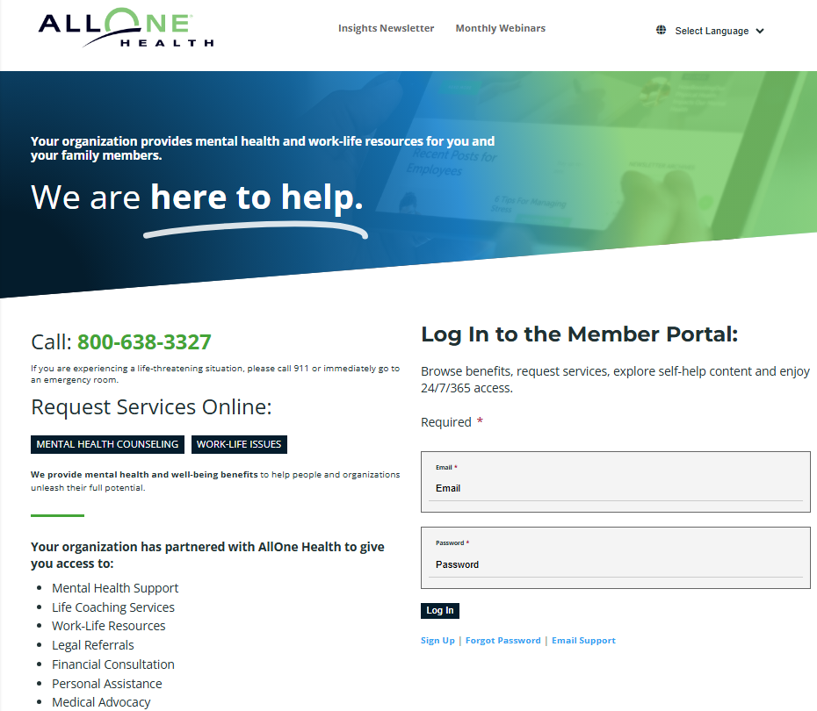

If you are a new member and need to create an account to access your member portal, here’s how:

- Click on Sign Up from the online member portal page.
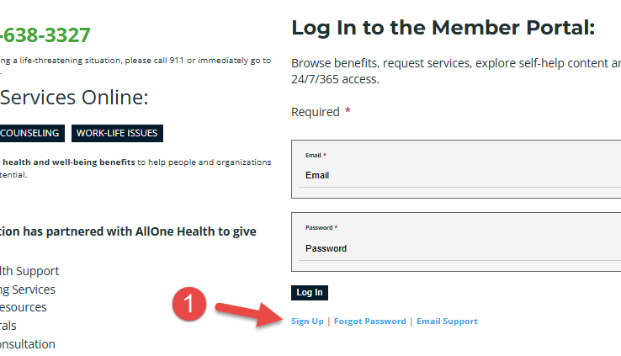

- OR –
2. Go to https://fei.mylifeexpert.com/signup.

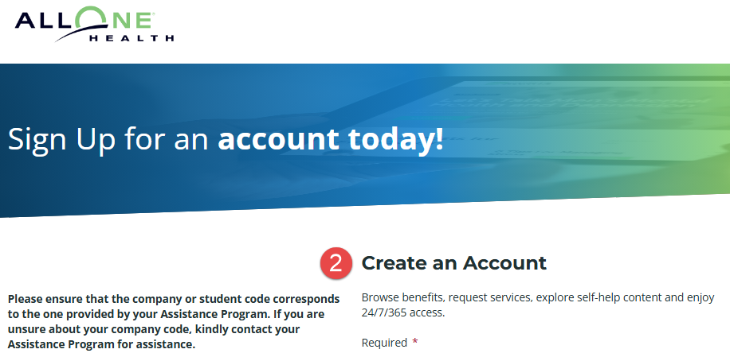

- Enter your corresponding agency’s Company Code listed below:
GBA Company Code - GBAEAP
GSFIC Company Code – GSFICEAP
SPC Company Code - SPCEAP
- Enter your Agency Email Address.
- Create and enter your Password.
- Click on Sign Up.
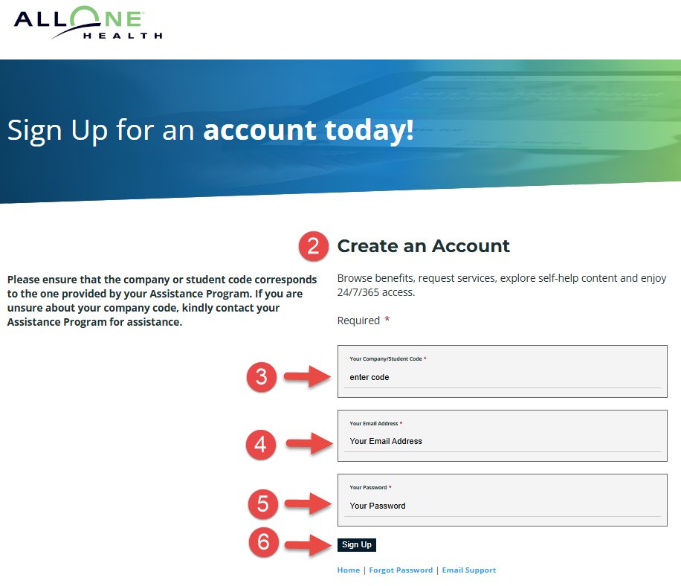
- If you have trouble logging in, click on Forgot Password or Email Support.
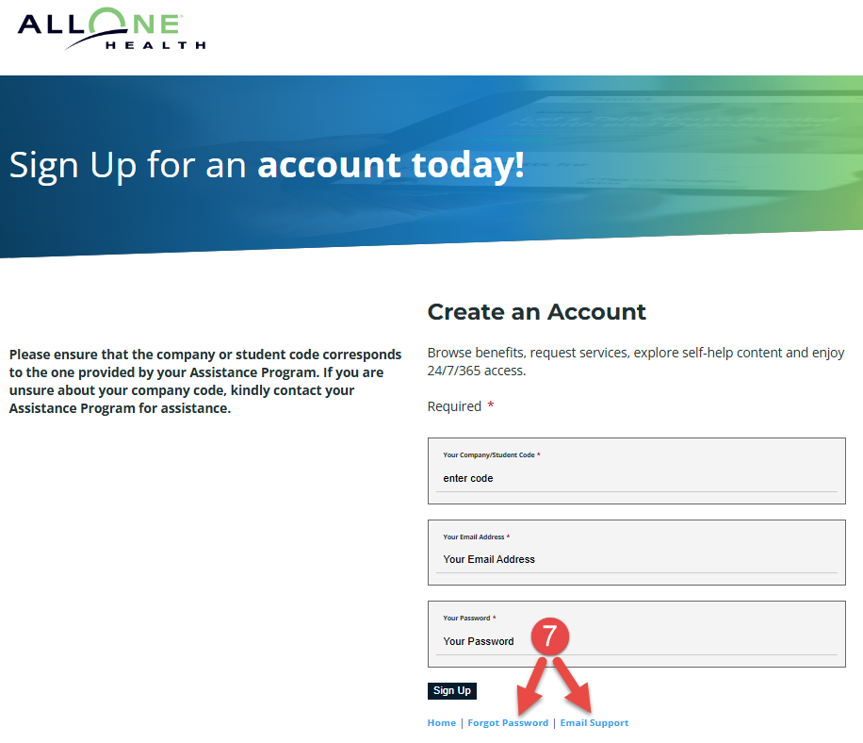

If you have questions, or need additional assistance, please contact me at your earliest convenience.

Thank you,
Sharon Burrow
Special Projects Facilitator
Georgia Building Authority
270 Washington Street, SW
Suite 1-124
Atlanta, GA 30334
(404) 652-1600 (O)
(404) 446-8588 (M)
sharon.burrow@gba.ga.gov
www.gba.georgia.gov

